**Use case Description**

**Overview:**

* **The user needs to book an appointment and then they will be redirected to the login page.**
* **If the user is new they need to register first else they will continue with the login page.**
* **Then they need to book their court by checking the availability, followed by it they need to mention their basic information such as number of individuals.**
* **Finally they need to make their payment and then the user can logout from the page**

**Relationships:**

* **The outline of the registration process for new users, registered users, and end users is communicated between the use case and the actors.**
* **Before making a badminton court reservation, new users must sign up using their own email ID after getting their email confirmation and address information.**
* **Registered users should first login via the login page and book the court depending on their availability.**
* **End users can directly log in through the login page, if they're a new user, they can sign up with their email address by providing their address information.**

**Flow of events:**

* **The customer needs to submit his state ID card before reservation for a court booking.**
* **At the back end, user checks and validates the ID Card given by the customer.**
* **If the customer is an old user then at the back end they validate the ID card with the help of a personal database and it gives the customer discount. The database checks whenever there is court booking it shows them the nearest locations and their regular booking availability and suggests them with all the avilabilities.**
* **If the customer is a new user then they will check the ID card and validate through the database records and the customer needs to pay through online .**

**Use case diagrams**

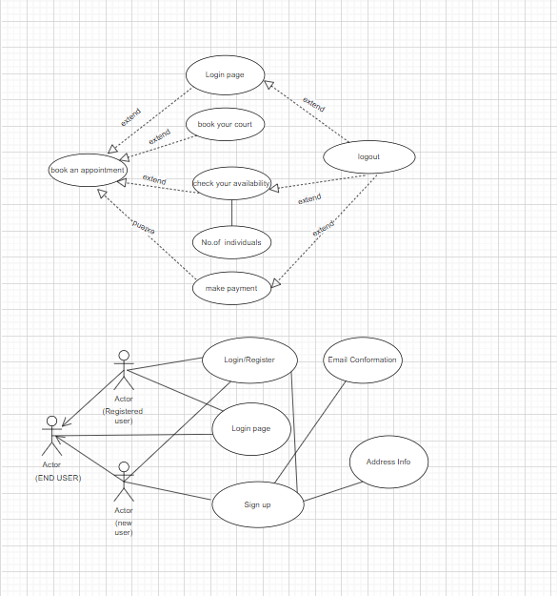

**Activity diagrams**

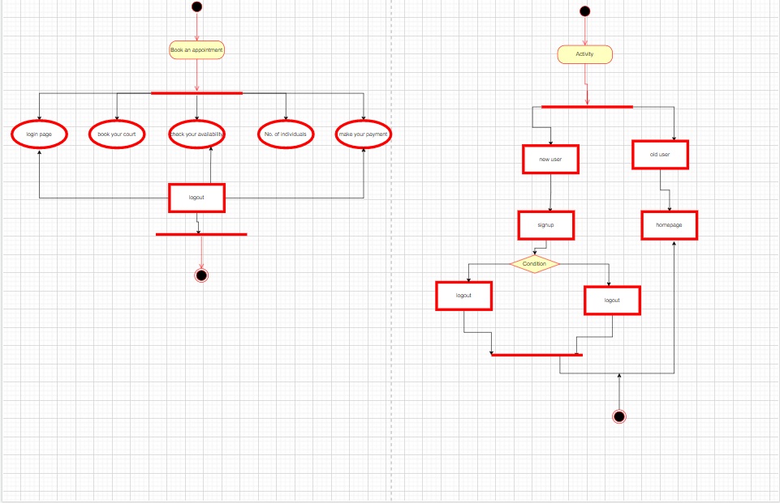

**Team member names:**

**Subhiksha Ravichandran(G02495764)**

**Venkata Sai Kavya Kannedari(G02494113)**

**Sahithi Reddy Kalijavedu(G02492753)**

**Sai Sujith Areti(G02494574)**